**ST. Xavier's College**

**(Affiliated to Tribhuvan University)**

**Maitighar, Kathmandu**



**Software Engineering**

**Assignment #02**

# SUBMITTED BY

**Utsav luitel**

**Roll No: 013BSCIT046**

**B. Sc. CSIT, 4th semester**

**SUBMITTED TO**

Department of Computer Science

St. Xavier’s College

Maitighar, Kathmandu

|  |
| --- |
| **Er. Sanjay Kumar Yadav**  Lecturer |
|  |

**Simplified Database System Organization**

A DBMS (database management system) is a collection of programs that enables users to create and maintain database. The DBMS is a common purpose software system that facilitates the process of constructing, defining, manipulating and sharing databases among various users as well as applications. Defining a database state the database involves specifying the constraints, data types and structures of the data to be stored in the database. The descriptive information is as well stored in the database in the form database catalogue or dictionary- it is called meta-data.

-Manipulating the data comprises the querying the database to retrieve the specific data.

-An application program accesses the database through transferring the quarries or requests for data to DBMS.

-The significant function provided by the DBMS includes protecting the database and maintain the database.

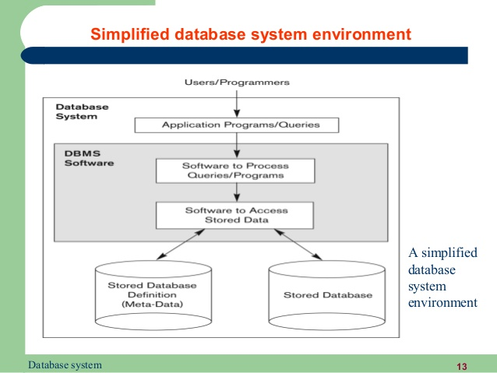

**Approach to management of data**

In order to remove all limitations of the File Based Approach, a new approach was required that must be more effective known as Database approach

There are basically two types of approaches of management of data

-File System Management

-DataBase approaches

File system approach is the traditional approach to data management. This was used when there was no database management software. With the development of DBMS, however, this approach is dwindling significantly, although it is still widely used in many organizations of our country. All data are kept in files in this approach, generally hardcopy, though softcopy is also possible (but for softcopy, anybody would prefer DBMS today). However, file system approach has many problems, e.g.:

- Slow and inefficient access of data

- Greater risks of errors/inaccuracy

- No or minimal sharing of data

- Low level of security

- No backup or difficulty in making backup

- Lack of networking

- Mostly manual

**DataBase approaches**

With the developments of effective advanced innovation and of capable DBMSs, document framework methodology appears to be exceptionally paltry today. We have capable database programming which is extremely proficient and secure that can take the breath away of conventional scholars of information administration. Everything is digitized and kept up with solid trustworthiness and security. Sharing and systems administration are empowered. In this way, lets condense these purposes of database methodology:

- Quick access

- Sharing

- Security

- Backup

- Networking

- Negligible dangers of mistakes

- Automated frameworks/advances

**Database vs. file system approaches**

Data abstraction

Data abstraction takes place in three levels in both approaches, though the mechanism is different in each. However, the level visible to the user is always only the view level. Figure 2 demonstrates the levels of abstraction and a brief idea of each level.

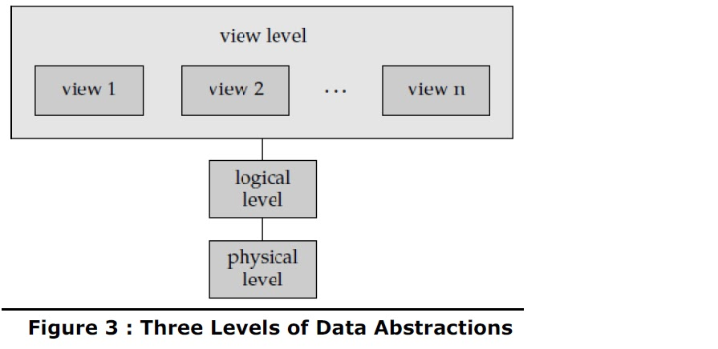

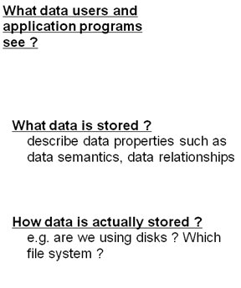

**Reliabilty**

A reliable DDBMS is one that can continue to process user requests even when the

underlying system is unreliable, i.e., failures occur

• Failures

– Transaction failures

– System (site) failures, e.g., system crash, power supply failure

– Media failures, e.g., hard disk failures

– Communication failures, e.g., lost/undeliverable messages

• Reliability is closely related to the problem of how to maintain the atomicity and

durability properties of transactions.

**Efficiency/performance**

-Focus on relational model

-Any column in a relational database can be searched for values.

-To improve efficiency indexes using storage structures such as BTrees and Hashing are used.

-But many useful functions are not indexable and require complete sacns of the database.

**3 layer architecture(ANSI/APARC architecture)**

An early proposal for a standard terminology and general architecture database a system was produced in 1971 by the DBTG (Data Base Task Group) appointed by the Conference on data Systems and Languages. The DBTG recognized the need for a two level approach with a system view called the schema and user view called subschema. The American National Standard Institute terminology and architecture in 1975.ANSI-SPARC recognized the need for a three level approach with a system catalog.

There are following three levels or layers of DBMS architecture:

1. Extenal Level

2. Conceptual Level

3. Internal Level

1. **External Level:** - External Level is described by a schema i.e. it consists of definition of logical records and relationship in the external view. It also contains the method of deriving the objects in the external view from the objects in the conceptual view.

2**. Conceptual Level**: - Conceptual Level represents the entire database. Conceptual schema describes the records and relationship included in the Conceptual view. It also contains the method of deriving the objects in the conceptual view from the objects in the internal view.

3. **Internal Level**: - Internal level indicates hoe the data will be stored and described the data structures and access method to be used by the database. It contains the definition of stored record and method of representing the data fields and access aid used.

A mapping between external and conceptual views gives the correspondence among the records and relation ship of the conceptual and external view. The external view is the abstraction of conceptual view which in turns is the abstraction of internal view. It describes the contents of the database as perceived by the user or application program of that view.

A mapping between conceptual records from the physical database.

**Advantages of the DBMS:**  
The DBMS serves as the intermediary between the user and the database. The database structure itself is stored as a collection of files, and the only way to access the data in those files is through the DBMS. The DBMS receives all application requests and translates them into the complex operations required to fulfill those requests. The DBMS hides much of the database’s internal complexity from the application programs and users.  
***The different advantages of DBMS are as follows.***  
1. **Improved data sharing.**  
The DBMS helps create an environment in which end users have better access to more and better-managed data. Such access makes it possible for end users to respond quickly to changes in their environment.  
**2. Improved data security.**  
The more users access the data, the greater the risks of data security breaches. Corporations invest considerable amounts of time, effort, and money to ensure that corporate data are used properly. A DBMS provides a framework for better enforcement of data privacy and security policies.  
**3. Better data integration.**  
 Wider access to well-managed data promotes an integrated view of the organization’s operations and a clearer view of the big picture. It becomes much easier to see how actions in one segment of the company affect other segments.  
**4. Minimized data inconsistency.**  
 Data inconsistency exists when different versions of the same data appear in different places. For example, data inconsistency exists when a company’s sales department stores a sales representative’s name as “Bill Brown” and the company’s personnel department stores that same person’s name as “William G. Brown,” or when the company’s regional sales office shows the price of a product as $45.95 and its national sales office shows the same product’s price as $43.95. The probability of data inconsistency is greatly reduced in a properly designed database.  
**5. Improved data access.**  
The DBMS makes it possible to produce quick answers to ad hoc queries. From a database perspective, a query is a specific request issued to the DBMS for data manipulation—for example, to read or update the data. Simply put, a query is a question, and an ad hoc query is a spur-of-the-moment question. The DBMS sends back an answer (called the query result set) to the application. For example, end users, when dealing with large amounts of sales data, might want quick answers to questions (ad hoc queries) such as:  
- What was the dollar volume of sales by product during the past six months?  
- What is the sales bonus figure for each of our salespeople during the past three months?  
- How many of our customers have credit balances of $3,000 or more?

**6.Improved decision making.**  
Better-managed data and improved data access make it possible to generate better-quality information, on which better decisions are based. The quality of the information generated depends on the quality of the underlying data. Data quality is a comprehensive approach to promoting the accuracy, validity, and timeliness of the data. While the DBMS does not guarantee data quality, it provides a framework to facilitate data quality initiatives.  
**7.Increased end-user productivity.**  
The availability of data, combined with the tools that transform data into usable information, empowers end users to make quick, informed decisions that can make the difference between success and failure in the global economy.  
  
**Disadvantages of Database:**  
  
Although the database system yields considerable advantages over previous data management approaches, database systems do carry significant disadvantages. For example:  
**1. Increased costs.**  
Database systems require sophisticated hardware and software and highly skilled personnel. The cost of maintaining the hardware, software, and personnel required to operate and manage a database system can be substantial. Training, licensing, and regulation compliance costs are often overlooked when database systems are implemented.  
**2. Management complexity.**  
Database systems interface with many different technologies and have a significant impact on a company’s resources and culture. The changes introduced by the adoption of a database system must be properly managed to ensure that they help advance the company’s objectives. Given the fact that database systems hold crucial company data that are accessed from multiple sources, security issues must be assessed constantly.  
**3. Maintaining currency.**  
To maximize the efficiency of the database system, you must keep your system current. Therefore, you must perform frequent updates and apply the latest patches and security measures to all components. Because database technology advances rapidly, personnel training costs tend to be significant. Vendor dependence. Given the heavy investment in technology and personnel training, companies might be reluctant to change database vendors. As a consequence, vendors are less likely to offer pricing point advantages to existing customers, and those customers might be limited in their choice of database system components.  
**4. Frequent upgrade/replacement cycles.**  
DBMS vendors frequently upgrade their products by adding new functionality. Such new features often come bundled in new upgrade versions of the software. Some of these versions require hardware upgrades. Not only do the upgrades themselves cost money, but it also costs money to train database users and administrators to properly use and manage the new features.

**Drawbacks of using file system to store data**

1. **Complexity** : The provision of the functionality that is expected of a good DBMS makes the DBMS an extremely complex piece of software. Database designers, developers, database administrators and end-users must understand this functionality to take full advantage of it. Failure to understand the system can lead to bad design decisions, which can have serious consequences for an organization.

2. **Size** : The complexity and breadth of functionality makes the DBMS an extremely large piece of software, occupying many megabytes of disk space and requiring substantial amounts of memory to run efficiently.

3. **Performance:** Typically, a File Based system is written for a specific application, such as invoicing. As result, performance is generally very good. However, the DBMS is written to be more general, to cater for many applications rather than just one. The effect is that some applications may not run as fast as they used to.

4. **Higher impact of a failure:** The centralization of resources increases the vulnerability of the system. Since all users and applications rely on the ~vailabi1ity of the DBMS, the failure of any component can bring operations to a halt.

5. **Cost of DBMS**: The cost of DBMS varies significantly, depending on the environment and functionality provided. There is also the recurrent annual maintenance cost.

6. **Additional Hardware costs:** The disk storage requirements for the DBMS and the database may necessitate the purchase of additional storage space. Furthermore, to achieve the required performance it may be necessary to purchase a larger machine, perhaps even a machine dedicated to running the DBMS. The procurement of additional hardware results in further expenditure.